**To Supply Leftover Food To Poor**

Project By,

Madhu Kondaiah Kandula

[21bq1a1266@vvit.net](mailto:21bq1a1266@vvit.net)

**About To Supply Leftover Food To Poor people:**

Salesforce has been involved in various corporate social responsibility (CSR) initiatives, including projects aimed at addressing hunger and food insecurity by leveraging its technology and platform for good. One specific type of project using Salesforce technology is food rescue and donation management systems. These systems are designed to streamline the process of connecting leftover food with those in need, improving food distribution to underserved populations, including poor communities.

**Set-Up Guide**

Creating a Salesforce Developer Account:

1. Visit Salesforce Developer Signup.

2. Fill out the signup form:

○. First Name & Last Name :Madhu Kondaiah Kandula

○. Email:21bq1a1266@vvit.net

○. Role: Developer

○. Company: VVIT

○. Country: India

○. Postal Code: 522414

○. Username: madhu66@gmail.com

2. Account Activation

-Check your email inbox for a verification email from Salesforce.

-Click Verify Account.

-Set up your password and security question, then click Change Password.

3. Creating Salesforce Objects

-Go to Object Manager and create the Custom Objects Like Venue,Drop-off point,Task,Volunteer,Execution Details.

**For example create drop-off point :**

### Create Drop-Off Point Object

To create an object:

1. From the setup page >> Click on Object Manager >> Click on Create >> Click on Custom Object.
   * Enter the label name >> Drop-Off Point
   * Plural label name>> Drop-Off Points
   * Enter Record Name Label and Format
   * Record Name >> Drop-Off point Name
   * Data Type >> Text
2. Click on Allow reports and Track Field History,Allow Activities
3. Allow search >> Save.

**4.Tabs:**

**To create custom tabs:**

A tab is like a user interface that is used to build records for objects and to view the records in the objects.

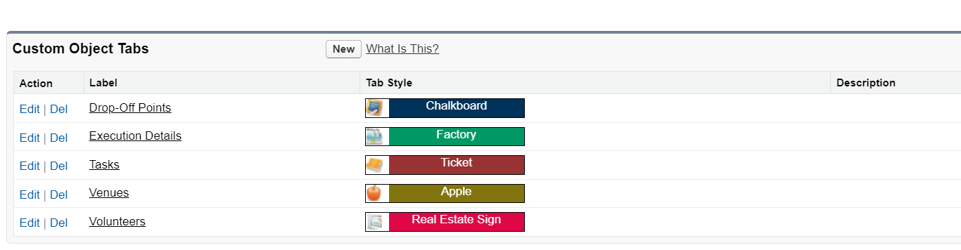

**Creation of fields for the objects**

For the Drop-off Point Object:

Go to setup >> click on Object Manager >> type object name(Drop-Off point) in search bar >> click on the object.

2. Now click on “Fields & Relationships” >> New

3. Select Data type as a “Geolocation” and Click on Next

4. Fill the Above as following:

* Field Label : Location 2
* Field Name : gets auto generated
* Description : Enter the Geolocation of the Drop off Point
* Geolocation Options : select Decimal
* Decimal Places : 4
* Click on Next >> Next >> Save and new.

To create another fields in an object:

1. Go to setup >> click on Object Manager >> type object name(Drop-Off point) in search bar >> click on the object.
2. Now click on “Fields & Relationships” >> New
3. Select Data type as a “Formula” and Click on Next
4. Fill the Above as following:

* Field Label : distance calculation
* Field Name : distance_calculation
* Formula Return Type : Number
* Formula Options : DISTANCE( Location_2__c , Venue__r.Location__c , 'km')
* Click on Next >> Next >> Save and new.

**Flows**

### Create Flow to create a record in Venue object

1. Go to setup >> type Flow in quick find box >> Click on the Flow and Select the New Flow.
2. Select the Screen flow. Click on create.

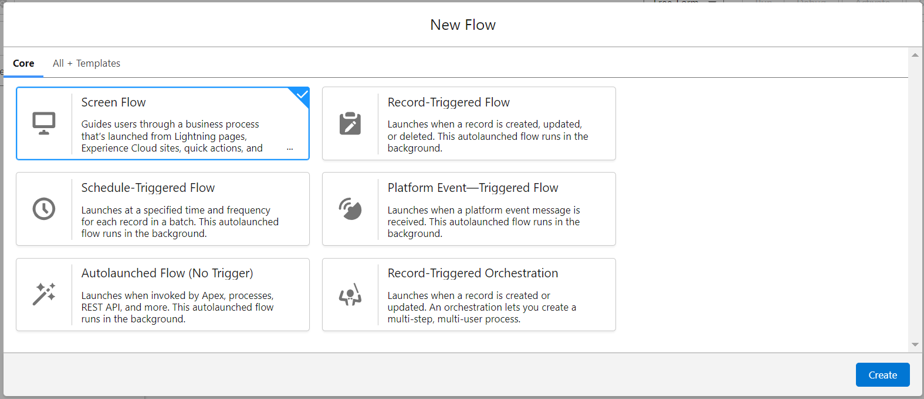

1. Click on the ‘+’ icon in between start and end, and click on screen element.
2. Under the Screen Properties:

Label : Venue Details

API Name : Venue_Details

1. Now lets add components in this flow. Click on Text Component and name it as:

Label : Venue Name

API Name : Venue_Name

1. Click on Email Component and name it as:

Label : Email

API Name : Contact_Email

1. Click on Phone Component and name it as:

Label : Phone

API Name : Contact_Phone

1. Click on Text Component and name it as:

Label : Venue Location

API Name : Venue_Location

1. Click on Number Component and name it as:

Label : Latitude

API Name : Latitude

1. Click on Number Component and name it as:

Label : longitude

API Name : longitude

1. Next click on Done.
2. Click on the ‘+’ icon in between Venue details and end, and click on create record element.
3. Now label it as

Label : Create Venue Record

API Name : Create_Venue_Record

How Many Records to Create : One

How to Set the Record Fields : Use separate resources, and literal values

Object : Venue

Set Field Values for the Venue : Click on ‘Add Field’ 5 times

Field : Value = Contact_Email__c : {!Contact_Email.value}

Field : Value = Contact_Phone__c : {!Contact_Phone.value}

Field : Value = Name : {!Venue_Name}

Field : Value = Venue_Location__c : {!location}

Field : Value = Location__Latitude__s : {!latitude}

Field : Value = Location__Longitude__s : {!longitude}

1. This would look like:

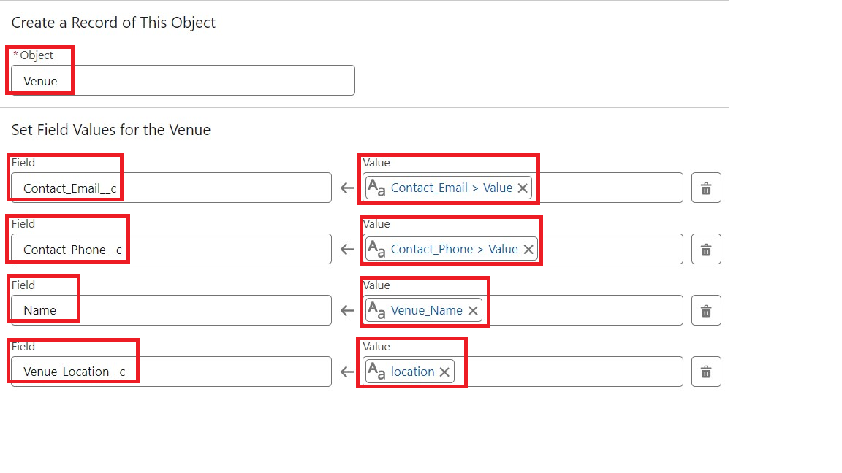

1. Click on Save as:

Flow Label : Venue Form

Flow API Name : Venue_Form

**Trigger Code:**

trigger DropOffTrigger on Drop_Off_point__c (before insert) {

for(Drop_Off_point__c Drop : Trigger.new){

Drop.Distance__c = Drop.distance_calculation__c;

}

}

**Creation Of Users:**

**User-1:**

1. Go to setup page >> type users in Quick Find bar >> click on users>> New user.
2. In General Information give details as: (Note : create users as per your wish NGO’s)

First Name : Iksha Foundation

Last Name : Iksha_Foundation

Alias : iiksh

Email : Give Your Email

Username : [ikshafoundation@sb.com](mailto:ikshafoundation@sb.com) (give the username different)

Nickname : Auto Populated

User License : Salesforce Platform

Profile : NGOs Profile

Active : Check

3.Click On Save.

**User-2,User-3:**

1. Create another Two Users by following steps in Activity - 1 with similar User License and Profile.
2. Give Different First Name, Last Name based on Different NGO’s.

**Creation Of Report :**

1. Go to the app(FoodConnect) >> click on the reports tab
2. Click on New Folder.

Folder Label : Custom Reports

Folder Unique Name : CustomReports

1. Open Custom Reports and click on New Report
2. Select Report Type : Venue with DropOff with Volunteer
3. Then click on Start Report.
4. In GROUP ROWS : Add Volunteer Name
5. In Columns : Add Venue Name, Drop-Off point Name, Distance.
6. Now click on Save & Run.
7. Give Label as :
8. Report Name : venue and Drop Off point
9. Report Unique Name : Auto Populated
10. Click on Select Folder and select Custom Report, then click on Save.

**Dashboards:**

### Adding venue and Drop Off point Report to the Dashboard

1. Go to the app(FoodConnect) >> click on the Dashboards tab.
2. Click on New Folder.

Folder Label : Custom Dashboards

Folder Unique Name : Auto Populated

1. Open Custom Dashboards and click on New Dashboards
2. Name : Organization Details
3. Click on Widget and select Chart or Table
4. In Select Report : Select venue and Drop Off point Report.
5. Then click on select
6. In Add Component:

Display As : Select Lightning Table Component Theme : Select Dark (Optional)

**Overview Of Dashboard:**

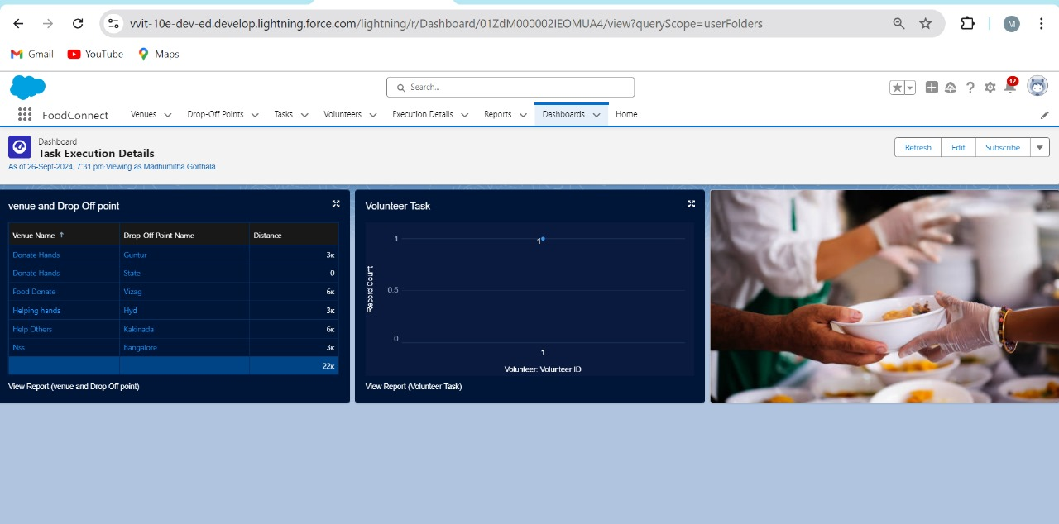

**Sharing Rules:**

1. Go to setup >> type Sharing Settings in quick find box >> Click on the Sharing Settings.
2. Scroll down and find Drop-Off point Sharing Rules.
3. Click on new near Drop-Off point Sharing Rules and Name it as:

Label : Rule 1

Rule Name : Rule_1

1. Select your rule type : Select Based on criteria.
2. Select which records to be shared:

Field : Operator : Value = Distance : less than : 15

1. Select the users to share with : Near Share With

Public Groups : Iksha

1. Click on Save.
2. Click on new near Drop-Off point Sharing Rules and Name it as:

Label : Rule 2

Rule Name : Rule_2

1. Select your rule type : Select Based on criteria.
2. Select which records to be shared:

Field : Operator : Value = Distance : greater than : 15

Field : Operator : Value = Distance : less or equal : 30

1. Select the users to share with : Near Share With

Public Groups : NSS

1. Click on Save.
2. Click on new near Drop-Off point Sharing Rules and Name it as:

Label : Rule 3

Rule Name : Rule_3

1. Select your rule type : Select Based on criteria.
2. Select which records to be shared:

Field : Operator : Value = Distance : greater than : 30

Field : Operator : Value = Distance : less or equal : 50

1. Select the users to share with : Near Share With

Public Groups : Street Cause

1. Click on Save.

**Creation Of HomePage:**

1. Go to setup >> type Lightning App Builder in quick find box >> Click on the Lightning App Builder and Select the New.
2. Select Home Page and give Label as HOME Page.
3. Select Standard Home Page.
4. Near Components search for Flow and Drag and Drop in Right Side Section..
5. On the right hand side:

Flow : Venue Flow

1. Near Components search for Dashboard, then Drag and Drop it in first Section.
2. Click on Save and Activation, then click on App Default, then Add Assignments.
3. Add FoodConnect App and then Save.
4. FoodConnect Home Page would Look Like this.

